Hello Everyone,

I Used SQL Server to perform in-depth analysis on Superstore data spanning from 2014 to 2016. Below, I showcase my findings and insights derived from this dataset:

Extraction of critical business insights such as:

* Sales trends over the years
* Regional performance analysis
* Customer segmentation based on purchasing behaviour
* Product category profitability
* Inventory management optimization

Through SQL queries and analytical techniques, I've highlighted key metrics and trends that offer valuable insights into business operations and strategies.

Best Regards

Imran Mirza

**Data Analysis for Sample Superstore**

1. **Write an SQL query to concatenate the Customer Name and Customer_ID for each order.**

1. **Write a query to find the length of the Customer_Name for each order.**

1. **Display the Product_Name in both uppercase and lowercase.**

1. **Extract the first 5 characters of the Order_ID**

1. **Query to remove leading and trailing spaces if any from the Customer_Name.**

1. **Write a query to left pad the Customer id field with zeros to ensure a length of 8 characters.**

1. **The query retrieves data from the years 2015**

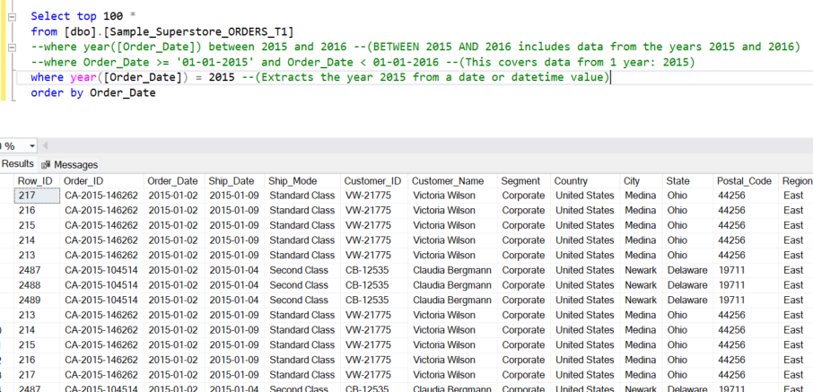

1. **Problem statement: Extract no’s for registered customers for the year 2015. This analysis excludes any records where the Customer_ID is null**

1. **Problem Statement: Calculating the frequency of each Order ID for each customer, sorted in descending order based on the frequency count. This analysis aims to provide insight into which Order IDs are most frequently placed by customers, sorted from highest to lowest frequency.**

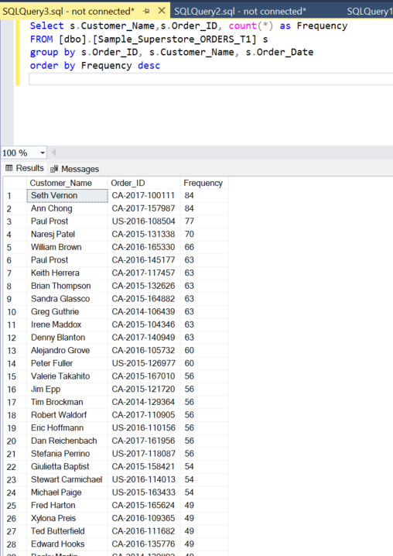

**10. Problem statement :Total sales for each customer for all orders placed for the year between 2015 and 2016**

**- This analysis aims to provide a sum of sales attributed to each individual customer.**

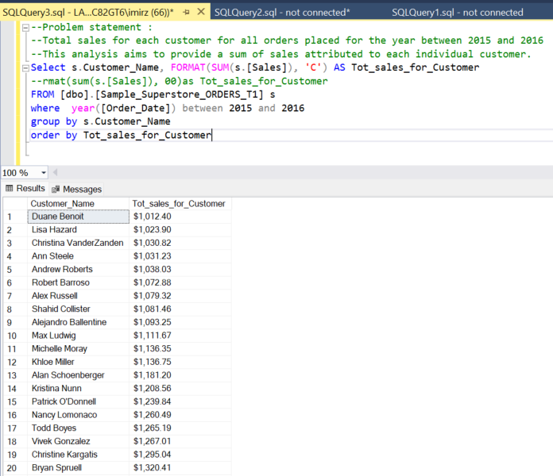

1. **Problem Statement: Show the count of customers in each region, sorted in descending order**

**11. Problem statement: Extract data for the top 3 customers with in each region**

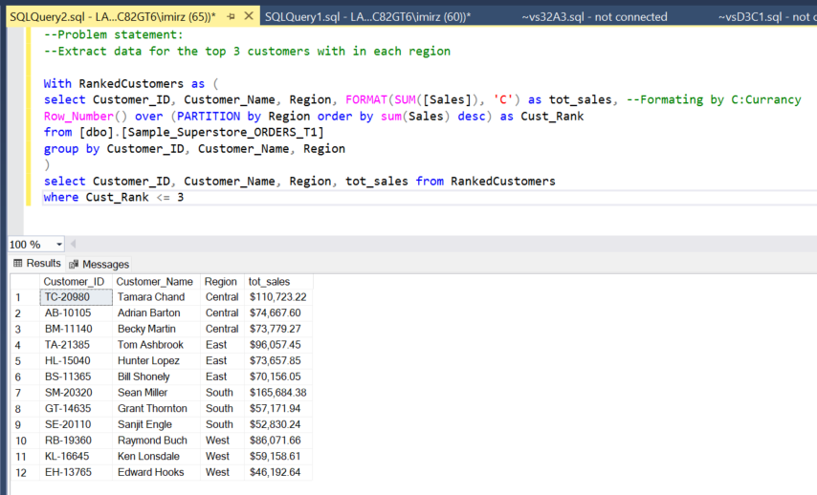

**12. Problem Statement: Extract the top 5 customers based on the total number of orders they have placed.**

**13. Problem statement: Calculate the total sales for each quarter of the year 2016.**

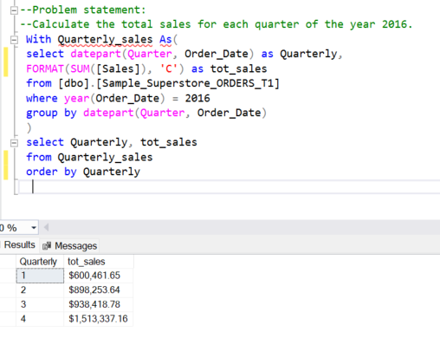

**14. Problem statement:Find the average number of days it takes for orders to ship after being placed for each shipping mode**

**15. Problem statement: Identify orders where the discount rate is greater than 50%.**

